Week 2 Report: Implementation of Responsive Web Design Project Name: Responsive Developer Portfolio Developer: Shashank B S (Intern) Submission Date: October 2026
1. Executive Summary This report documents the design decisions, technical architecture, and problem-solving strategies applied during the creation of a responsive developer portfolio. The primary goal of this task was to develop a website from scratch that adjusts its layout gracefully across desktops, tablets, and smartphones. The resulting web page serves as a responsive professional showcase, utilizing a mobile-first approach, fluid images, CSS Flexbox, and CSS Grid to ensure seamless adaptability across all device viewports.
2. HTML5 Architecture & Design Hierarchy The web page's structural foundation was built using clean HTML5 semantic elements to maximize accessibility, SEO, and logical content flow:
- Header & Navigation (<header>, <nav>): Contains the branding and dynamic navigation links designed to stack or align horizontally based on screen width.
- Hero Section (<section class="hero-section">): Structured as a central focal point to introduce the developer profile and primary call-to-action button.
- Content Modules (<section>): Organized cleanly into modular, scalable sections:
  - skills: Utilizes a flexible container for individual skill cards, allowing them to wrap dynamically.
  - projects: Houses project cards (including Digital Raitha and Quantnova) within a responsive grid container, accompanied by fluid image assets.
- Footer (<footer>): Simple copyright notice anchoring the bottom of the page.
3. CSS3 Styling, Layout Strategy & Micro-interactions The visual styling and layout engines were crafted to establish a modern, tech-forward aesthetic while strictly adhering to responsive principles:
- Mobile-First Base: CSS rules were initially written for small viewports, ensuring faster rendering on mobile devices before progressively enhancing the layout for larger screens.
- Flexbox Layout Engine: Flexbox was used in the navigation bar and skills section to allow items to wrap dynamically (flex-wrap: wrap) and center effectively without fixed dimensions.
- CSS Grid: Implemented for the project gallery (display: grid), allowing the layout to seamlessly transition from a single column to multiple columns based on available width.
- Fluid Assets: All images within project cards were assigned fluid properties (width: 100%; height: auto;) to prevent overflow and maintain native aspect ratios.
- Global Reset: Implemented a universal CSS reset (* { margin:0; padding:0; box-sizing:border-box; }) to ensure uniform element dimensions across different browser rendering engines.
4. Responsiveness & Media Queries To ensure the webpage renders fluidly on desktops, tablets, and smartphones, media queries targeting progressive viewports were integrated:
- Mobile (Base Styles - Under 768px): The navigation links stack vertically under the logo (flex-direction: column), and the project grid is restricted to a single column (grid-template-columns: 1fr) to prevent horizontal scrolling.
- Tablet Breakpoint (min-width: 768px): Navigation elements shift to a horizontal row (flex-direction: row) with space-between alignment. The hero typography scales up, and the project grid expands to two columns (grid-template-columns: repeat(2, 1fr)).
- Desktop Breakpoint (min-width: 1024px): The main container width is constrained to 80% (max 1200px) to prevent over-stretching on ultra-wide monitors. The project gallery expands to a three-column grid (grid-template-columns: repeat(3, 1fr)).
5. Challenges Encountered & Problem Solving
- Navigation Real Estate on Mobile:
  - Issue: Horizontal navigation links caused layout breakage and text overlapping on narrow smartphone screens.
  - Solution: Applied flex-direction: column in the base mobile CSS to stack the links neatly, utilizing a media query at the 768px breakpoint to switch back to a horizontal layout.
- Image Overflow and Aspect Ratio Distortion:
  - Issue: Fixed-width images broke the CSS grid containers when scaling down to mobile viewports.
  - Solution: Removed fixed width/height declarations from the HTML and applied a .fluid-img CSS class (width: 100%; height: auto; display: block;). This allowed the grid to dictate the container size while the images scaled proportionally.
6. Screenshots
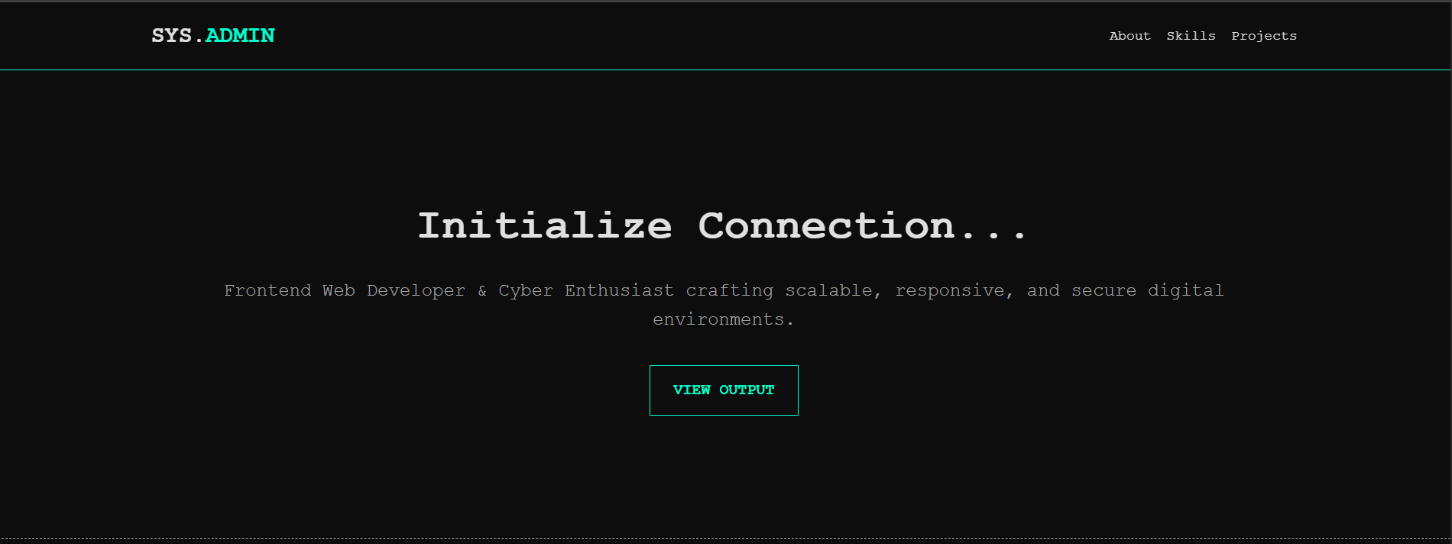

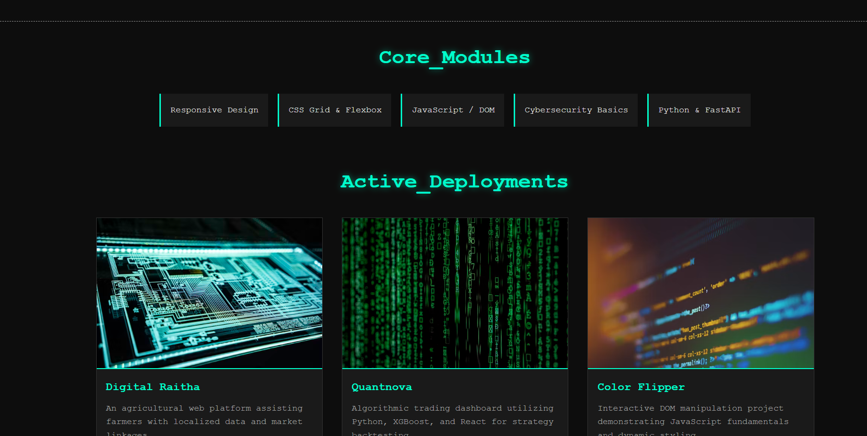

7. Conclusion The developed responsive portfolio meets all practical and aesthetic requirements of the Week 2 task. The implementation demonstrates proficiency in modern HTML5 semantic markup, mobile-first CSS styling, advanced layout engines (Flexbox and Grid), and media query integration to achieve a seamless multi-device user experience.

